Nanocomposite materials for 3Dprinting
Introduction
3D printing is an additive manufacturing (AM) technique for fabricating a wide range of structuresand complex geometries from 3D model data. The process consists of printing successive layers ofmaterials that are formed on top of each other. The technology was developed by Charles Hull in1986 using stereolithography (SLA), and subsequently developed to include powder bed fusion,fused deposition modelling (FDM), inkjet printing, and contour crafting (CC). 3D printing, whichinvolves various methods, materials, and equipment, has evolved over the years, and can be usedto transform manufacturing and logistics processes. Additive manufacturing is widely applied indifferent industries, including construction industries, manufacturing of prototypes, andbiomechanical industries. [1] As AM technology develops, efforts have been made to apply thetechnology in several fields, as shown in Figure 5.1.
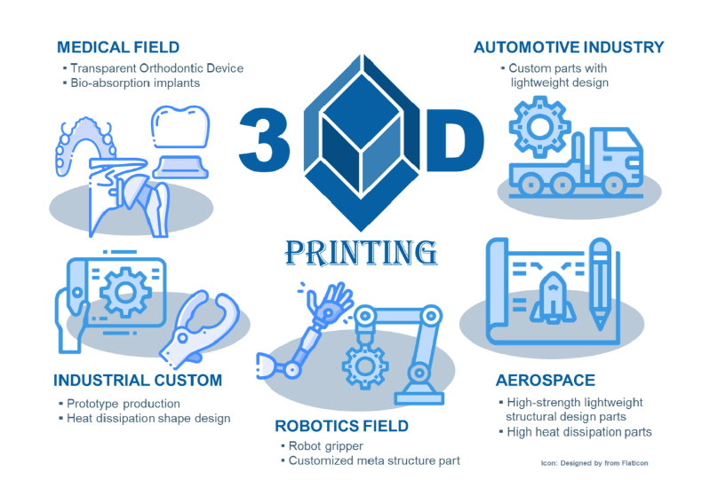
FIGURE 5.1 Application of 3D printing in different industries [2].
New applications for novel materials are emerging, and AM methods are continuously beingdeveloped. One of the main drivers for this technology to become more accessible is the expiry ofearlier patents, which has given manufacturers the capability to develop new 3D printing devices.Recent developments have reduced the cost of 3D printers, thereby expanding their application inschools, homes, libraries, and laboratories. Initially, 3D printing was extensively used by architectsand designers to produce aesthetic and functional prototypes owing to its rapid and cost-effective prototyping capabilities. The use of 3D printing minimises additional expenses incurred duringproduct development. However, in the past few years, 3D printing has been fully utilised in variousmanufacturing processes, from the production of prototypes to products. Product customisationhas been a challenge for manufacturers because of the high cost associated with the production oftailor-made products for end users. In contrast, small quantities of customised products can be 3Dprinted at relatively low costs using AM. This is specifically useful in the biomedical field, whereinunique patient-customised products are typically required. Customised functional products aregaining attention in the field of 3D printing, as predicted by Wohlers Associates, who envisionedthat approximately 50% of 3D printing will involve the manufacturing of commercial products in2020. [3]
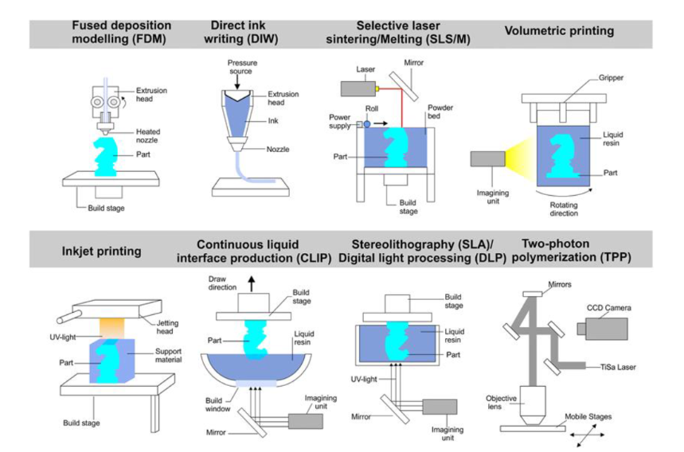
FIGURE 5.2 Schematic summary of the different 3D printing techniques. [4]
Mass customisation is an advantage of 3D printing; i.e., each product can be modified according tothe user's characteristics while maintaining a low price through mass production. 3D printing hasno mould or additional requirements compared to traditional production methods. In addition, asmoulds are not required, there is no cost involved in changing the design of the product. Therefore,the advantage of 3D printing is not its lower price with mass production, but its ability to producevarious shapes at low prices. However, AM requires further investigation because the high cost andtime consumption of the process are not suitable for simple mass production.A variety of materials, including metals, ceramics, and concrete, can be used in 3D printing.
However, this Chapter focuses on the use of polymers in 3D printing.As shown in Figure 5.2, 3D printing of polymers can be divided into two methods: moulding, in
which heat is applied to the polymer, and photocuring, in which a resin with an acrylic functionalgroup is selectively cured by UV irradiation. This Chapter provides details on both methods.The impact of 3D printing on the 4th industrial revolution and our lives is still unknown. This isbecause the extent to which the technology can be improved is still unknown. However, various 3Dprinting methods have already been developed, and further studies are being conducted on avariety of printing methods and their corresponding materials. In the next section, the mostrepresentative 3D printing methods will be briefly introduced. 3D printed materials tend to havelower mechanical strength compared to conventional injection-moulded materials. Thisphenomenon is related to the inevitable structural defects that occur during 3D printing; however,to overcome these limitations, nanocomposite material technology can be applied to 3D printing.
Additive manufacturing (3D printing) has the potential to produce new types of multifunctionalnanocomposites. The ability to print complex 3D objects layer by layer provides the opportunity totake advantage of nanomaterial AM to better control material properties at the component level. Functionalisation through the combination of nanomaterials and printing materials can becharacterised by increased thermal and electrical conductivity, increased strength, and reducedweight. By applying a new paradigm to nanocomposite functionality, we can discuss the promise ofnanomaterial-based AM. [5], [6]
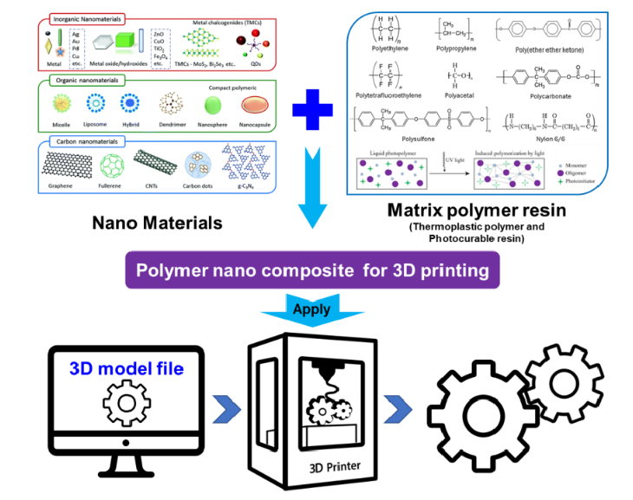
FIGURE 5.3Conceptual schematic diagram of 3D printing using nanocomposite technology. [7] Reproduced withpermission. Copyright 2018, Springer Nature.

Nanocomposite preparation for 3D printing
Different 3D printing methods have been developed to prepare nanocomposites. These methodsvary depending on the nature of the nanofiller and the resin. The main objective is to achieve ahomogeneous mixture with an adequate viscosity to obtain high-quality printed products. Shearmixing, mechanical mixing, sonication, ultrasonication, or a combination of these methods mayattain homogeneity.Thermoplastics are the most commonly used materials for 3D printing, as they can be melted andreformed into the envisioned shape. While these materials have been extensively used in thefabrication of prototypes, they characteristically lack the chemical, mechanical, and thermalstability required for use in functional or load-bearing components for industrial applications. [51]Therefore, the incorporation of nanomaterials into thermoplastics to increase their thermal,chemical, and mechanical properties have gained interest .Ning et al. [52] used the FDM process to create functional parts using carbon fibre-reinforcedmaterials as feedstock.
The type of plastic resin used heavily influenced the mechanical strength ofthe final product, as well as the length and loading of the carbon fibres. Carbon fibres (150 μm/100μm) were used as reinforcing materials to improve the mechanical strength of ABS thermoplastics.The resulting composite, containing 5 wt% carbon fibres, showed a >20% increase in the Young’smodulus and tensile strength of the material compared to the original ABS thermoplastic. Similarly,Yi et al. [53] used selective laser sintering (SLS) to develop and fabricate carbon/carbon (C/C)composite components, which achieved high precision and good mechanical performance. Carbonnanomaterials, such as graphene and carbon nanotubes, have unique physical and chemicalproperties that can improve the tensile properties and thermal stability of plastic materials. [54] An investigation into polyurethane/poly(lactic acid)/graphene oxide nanocomposites (TPU/PLA/GO)by Chen et al. [20] showed that the addition of GO nanofillers to a TPU and PLA nanocompositeimproved its mechanical properties and thermal stability. In addition, the mechanical behaviour ofthe TPU/PLA/GO nanocomposite is strongly dependent on its printing orientation. Additionally,they reported that the 3D printed nanocomposite exhibits good biocompatibility with NIH3T3 cells,showing potential as a biomaterial scaffold for tissue engineering applications.Dul et al. [54] studied graphene nanoplatelets/acrylonitrile butadiene styrene composites. Ananofiller containing 4-wt% graphene nanoplatelets was introduced into the ABS matrix by meltblending. The results showed that the addition of graphene nanoplatelets increased the elasticmodulus of pure ABS by nearly 30%. In addition to the improved elastic modulus, the graphenenanoplatelets improved the thermal stability by improving the coefficient of thermal expansion andcreep compliance. Similarly, Zhuang et al. [55] studied graphene-doped polylactic acid/polylacticacid (G-PLA/PLA) composites by using pure PLA and graphene-doped polylactic acid (G-PLA) asfilament materials in the dual-head printing method. The results showed that by controlling theprinting parameters, the ratio of PLA to G-PLA could be varied; a higher content of G-PLA reducedthe electrical resistance of the thermoplastic composites.Torrado et al. [56] studied titanium oxide/acrylonitrile butadiene styrene composites and examinedthe effect of compounding 5 wt% titanium dioxide (TiO2) nanoparticles with ABS. The resultsshowed that there was no significant difference observed in the tensile strength of the pure ABSprinted component (16.23 ± 3.07 MPa) compared to that of the ABS/TiO2 printed component(16.22 ± 3.53 MPa). The addition of TiO2 nanoparticles improved the tensile strength of thecomposite, however, varying the TiO2 filler size slightly affected its properties. Functionalizationwith TiO2 before melt blending decreased agglomeration and enriched the particle distribution inthe polymer matrix.
FDM printing of nanomaterials using polybutylene terephthalate (PBT) reinforced with fillers (multi-walled carbon nanotubes and graphene), was reported by Gnanasekaran et al. [57] The resultsshowed that the 3D printed PBT/CNT composites exhibited better conductive properties, elasticbehaviour, and printability than the PBT/graphene printed composites. This is because voidformation during printing led to brittleness and surface roughness for the PBT/graphene 3D printedcomposites.Guo et al. [58] studied cloisite/polylactic acid composites and developed a flame-retardantthermoplastic composite by using a Cloisite 30B (C-30B) nanoclay filler and PLA with melaminepolyphosphate (MPP) as a matrix. The nanocomposites were prepared by melt blending and thentreated as filaments using a single screw extruder. The PLA/MPP polymer composites showed poorheat conduction, resulting in flame resistivity and significantly decreased mechanical properties.However, the addition of the C-30B nanoclay fillers improved the mechanical properties of thethermoplastic nanocomposites. The modulus and tensile strength of the 3D printed PLA/MPP/C30Bnanocomposites were 3.91 ± 0.22 GPa and 70.0 ± 3.8 MPa, respectively.

